**NOME: Matheus Amarante 2C**

**1) Selecione nome e dataNascimento dos alunos que começam com a letra "X".**

[SELECT](http://localhost/phpmyadmin/url.php?url=https://dev.mysql.com/doc/refman/5.5/en/select.html) nome,datanascimento FROM `alunos` WHERE nome [like](http://localhost/phpmyadmin/url.php?url=https://dev.mysql.com/doc/refman/5.5/en/string-comparison-functions.html" \l "operator_like" \t "mysql_doc) 'm%'

**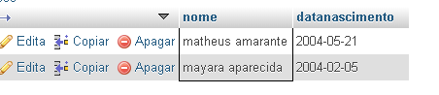**

**2)Selecione nome e telefone dos alunos que nasceram no mês x;**

[SELECT](http://localhost/phpmyadmin/url.php?url=https://dev.mysql.com/doc/refman/5.5/en/select.html) nome,telefone FROM `alunos` WHERE month(datanascimento)='07'

****

**3)Selecione nome e telefone dos alunos que nasceram no ano x;**

[SELECT](http://localhost/phpmyadmin/url.php?url=https://dev.mysql.com/doc/refman/5.5/en/select.html) nome, telefone FROM `alunos` WHERE [year](http://localhost/phpmyadmin/url.php?url=https://dev.mysql.com/doc/refman/5.5/en/date-and-time-types.html" \t "mysql_doc)(datanascimento)='2004'

**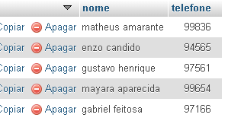**

**4) Ordene os alunos em ordem decrescente por Turma;**

[SELECT](http://localhost/phpmyadmin/url.php?url=https://dev.mysql.com/doc/refman/5.5/en/select.html) \* FROM `alunos` ORDER BY turma desc

**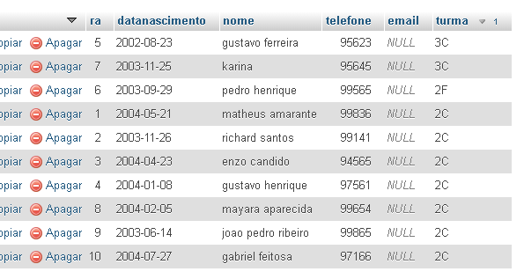**

**5) Selecione os livros do Gênero "X";**

[SELECT](http://localhost/phpmyadmin/url.php?url=https://dev.mysql.com/doc/refman/5.5/en/select.html) titulo, autor, genero FROM `livros` WHERE genero [LIKE](http://localhost/phpmyadmin/url.php?url=https://dev.mysql.com/doc/refman/5.5/en/string-comparison-functions.html#operator_like) '%Literatura%'

**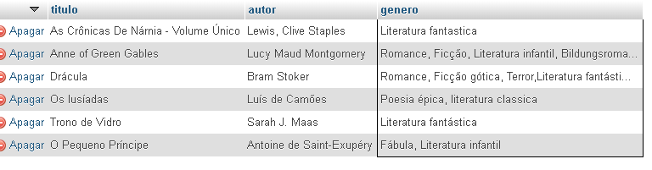**

**6) Quantos livros tem cadastrados;**

[SELECT](http://localhost/phpmyadmin/url.php?url=https://dev.mysql.com/doc/refman/5.5/en/select.html) [COUNT](http://localhost/phpmyadmin/url.php?url=https://dev.mysql.com/doc/refman/5.5/en/group-by-functions.html#function_count)(\*) from livros

**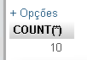**

**7) Selecione os livros do autor "X";**

[SELECT](http://localhost/phpmyadmin/url.php?url=https://dev.mysql.com/doc/refman/5.5/en/select.html) titulo,autor,genero FROM `livros` WHERE autor [like](http://localhost/phpmyadmin/url.php?url=https://dev.mysql.com/doc/refman/5.5/en/string-comparison-functions.html" \l "operator_like" \t "mysql_doc) '%RICARDO%'

**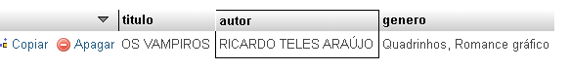**

**8) Selecione os empréstimos que aconteceram no mes "X";**

[SELECT](http://localhost/phpmyadmin/url.php?url=https://dev.mysql.com/doc/refman/5.5/en/select.html) \* FROM `emprestimo\_devolucao` WHERE month(data\_emprestimo) = '10'

**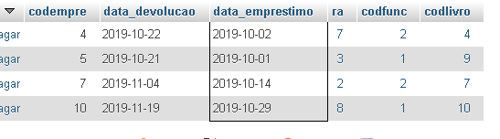**

**9) Selecione os empréstimos que aconteceram entre os anos "X" e "Y";**

[SELECT](http://localhost/phpmyadmin/url.php?url=https://dev.mysql.com/doc/refman/5.5/en/select.html) data\_emprestimo,data\_devolucao,ra FROM `emprestimo\_devolucao` WHERE data\_emprestimo BETWEEN '2019-01-01' [and](http://localhost/phpmyadmin/url.php?url=https://dev.mysql.com/doc/refman/5.5/en/logical-operators.html" \l "operator_and" \t "mysql_doc) '2020-12-31'

**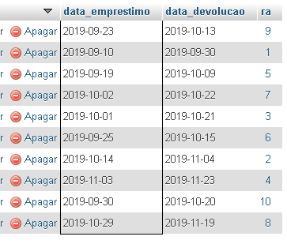**

**10) Selecione os bibliotecarios que são da cidade "X";**

[SELECT](http://localhost/phpmyadmin/url.php?url=https://dev.mysql.com/doc/refman/5.5/en/select.html) nome, telefone, cidade FROM `bibliotecario` WHERE cidade = 'Ribeirão Pires'

**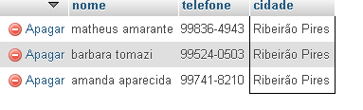**

**11)Ordene os bibliotecarios em ordem alfabética;**

[SELECT](http://localhost/phpmyadmin/url.php?url=https://dev.mysql.com/doc/refman/5.5/en/select.html) \* FROM `bibliotecario` ORDER by nome

**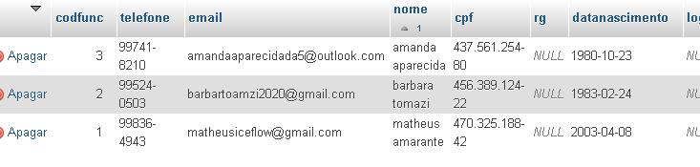**

**12) Ordene os livros por gênero;**

[SELECT](http://localhost/phpmyadmin/url.php?url=https://dev.mysql.com/doc/refman/5.5/en/select.html) \* FROM `livros` order by gênero

**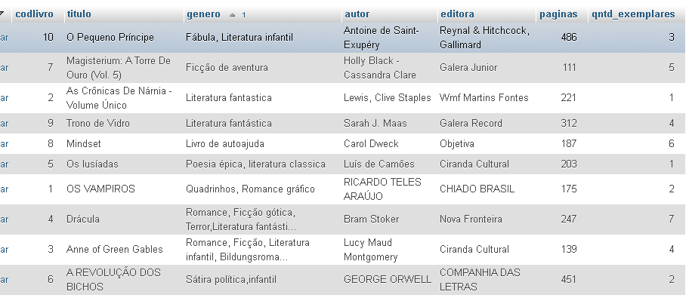**

**13) Selecione os livros da editora "X";**

[SELECT](http://localhost/phpmyadmin/url.php?url=https://dev.mysql.com/doc/refman/5.5/en/select.html) \* FROM `livros` WHERE editora [like](http://localhost/phpmyadmin/url.php?url=https://dev.mysql.com/doc/refman/5.5/en/string-comparison-functions.html" \l "operator_like" \t "mysql_doc) '%Objetiva%

****

**14) Selecione os livros dos autores "X" ou genero "Y" e que tenham menos de "Z" páginas;**

[SELECT](http://localhost/phpmyadmin/url.php?url=https://dev.mysql.com/doc/refman/5.5/en/select.html) titulo,autor,genero,paginas FROM `livros` WHERE (autor [like](http://localhost/phpmyadmin/url.php?url=https://dev.mysql.com/doc/refman/5.5/en/string-comparison-functions.html#operator_like) '%Luis%' [or](http://localhost/phpmyadmin/url.php?url=https://dev.mysql.com/doc/refman/5.5/en/logical-operators.html#operator_or) genero [like](http://localhost/phpmyadmin/url.php?url=https://dev.mysql.com/doc/refman/5.5/en/string-comparison-functions.html#operator_like) '%Fantastica%') [and](http://localhost/phpmyadmin/url.php?url=https://dev.mysql.com/doc/refman/5.5/en/logical-operators.html" \l "operator_and" \t "mysql_doc) paginas >100

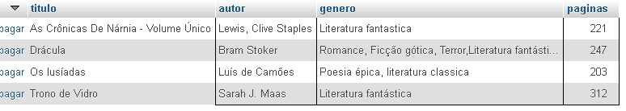

**15) Selecione os livros com titulo que começam com a letra "X" e genero "X";**

[SELECT](http://localhost/phpmyadmin/url.php?url=https://dev.mysql.com/doc/refman/5.5/en/select.html) Titulo,genero FROM `livros` WHERE titulo [like](http://localhost/phpmyadmin/url.php?url=https://dev.mysql.com/doc/refman/5.5/en/string-comparison-functions.html#operator_like) 'M%' [and](http://localhost/phpmyadmin/url.php?url=https://dev.mysql.com/doc/refman/5.5/en/logical-operators.html#operator_and) genero [like](http://localhost/phpmyadmin/url.php?url=https://dev.mysql.com/doc/refman/5.5/en/string-comparison-functions.html" \l "operator_like" \t "mysql_doc) '%Ficção%'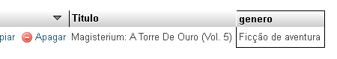

**16) faça a média de paginas de todos os livros;**

[SELECT](http://localhost/phpmyadmin/url.php?url=https://dev.mysql.com/doc/refman/5.5/en/select.html) [avg](http://localhost/phpmyadmin/url.php?url=https://dev.mysql.com/doc/refman/5.5/en/group-by-functions.html" \l "function_avg" \t "mysql_doc)(paginas) from livros

**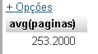**

**17) faça a soma de páginas de todos os livros;**

[SELECT](http://localhost/phpmyadmin/url.php?url=https://dev.mysql.com/doc/refman/5.5/en/select.html) [SUM](http://localhost/phpmyadmin/url.php?url=https://dev.mysql.com/doc/refman/5.5/en/group-by-functions.html#function_sum)(paginas) from livros

**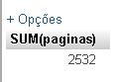**

**18) Selecione os livros que tenham entre 4 e 6 exemplares**

[SELECT](http://localhost/phpmyadmin/url.php?url=https://dev.mysql.com/doc/refman/5.5/en/select.html) titulo, autor, genero, qntd\_exemplares FROM `livros` WHERE qntd\_exemplares BETWEEN 4 [and](http://localhost/phpmyadmin/url.php?url=https://dev.mysql.com/doc/refman/5.5/en/logical-operators.html" \l "operator_and" \t "mysql_doc) 6

**